Assignment # 3

|  |  |  |  |  |  |  |  |  |  |  |  |  |  |
| --- | --- | --- | --- | --- | --- | --- | --- | --- | --- | --- | --- | --- | --- |
| Project Title: | | | | | | | | | | | | | |
| **<Library Management System>** | | | | | | | | | | | | | |
| Group Leader (GL): | | | | | | | | | | | | | |
| 1. | | Name: | | **Raghib Uddin** | | | | | | | | | |
|  | | Reg #: | | 13273 | | | | | | | | | |
|  | | CGPA: | | 2.5 | | | | | | | | | |
|  | | Mobile # : | | 03350367621 | | Email: | | | | Raghib.13273@iqra.edu.pk | | | |
|  | | Signature: | | Raghib | | | | | | | | | |
|  | |  | | | | | | | | | | | |
| **Group Members (GM’s):** | | | | | | | | | | | | | |
| 2. | | Name: | | **M Hamza Khan** | | | | | | | | | |
|  | | Reg #: | | 13490 | | | | | | | | | |
|  | | CGPA: | | 2.3 | | | | | | | | | |
|  | | Mobile # : | | 03015491521 | | | | Email: | | | | Muhammad.13490@iqra.edu.pk | |
|  | | Signature: | | Hamza | | | | | | | | | |
|  | |  | | | | | | | | | | | |
| 3. | | Name: | | **Binyamin** | | | | | | | | | |
|  | | Reg #: | | 13402 | | | | | | | | | |
|  | | CGPA: | | 2.37 | | | | | | | | | |
|  | | Mobile # : | | 03029705951 | | | | Email: | | | | Bin.13402@iqra.edu.pk | |
|  | | Signature: | | Binyamin | | | | | | | | | |
|  | |  | | | | | | | | | | | |
| Group Member (GM ’s): | | | | | | | | | | | | | |
| 4 | | Name: | | **S.M Umer Ali** | | | | | | | | | |
|  | | Reg #: | | 13601 | | | | | | | | | |
|  | | CGPA: | | 2.19 | | | | | | | | | |
|  | | Mobile # : | | 03133333609 | | Email: | | | | Syed.13601@iqra.edu.pk | | | |
|  | | Signature: | | Umer | | | | | | | | | |
|  | |  | | | | | | | | | | | |
| **Group Members (GM’s):** | | | | | | | | | | | | | |
| 5 | | Name: | | **Muhammad Uzair** | | | | | | | | | |
|  | | Reg #: | | 12860 | | | | | | | | | |
|  | | CGPA: | | 2.4 | | | | | | | | | |
|  | | Mobile # : | | 03312806306 | | | | Email: | | | | Muhammad.12860@iqra.edu.pk | |
|  | | Signature: | | Uzair | | | | | | | | | |
|  | |  | | | | | | | | | | | |
|  | |

**Phase3: Requirement Analysis**

* Define all the functional and non-functional requirements of your project.

1. **Add New User**
2. User Request for Registration
3. librarian Add new user to system
4. Enter all valid detail for registration form
5. Generate a unique Id for registration

* **Functional Requirement**

1. A new user which is not registered in the system
2. Registration form must be avaliable
3. Detail must me correct

**2. Issue Book**

1. Request for issuing a specific book
2. Student Book limit is avaliable than book will be issue
3. Limit exceed than book will not be issue

* **Functional Requirement**

1. Member must be registered against unique Id
2. Books must be Available
3. We must have librarian account which manages the whole system

**3.Return Book**

1. Request for returning book
2. Get member Id and check return Date
3. Return book
4. Date Exceed

* **Functional Requirement**

1. Member and issued book must have unique Id
2. Issued book must be Available

4. **Add New Book Category**

1. New category book avaliable
2. Book is for existing category librarian add it to existing category
3. Book is for new category librarian create new category
4. This feature is for medium priority

* **Functional Requirement**

1. New category Book must be Available

**NON-Functional Requirement**

* **Performance requirements**

1. Performance of the system must be fast and accurate
2. System shall handle expected and unexpected errors
3. should be able to handle large amount of data

* **Security Requirements**

1. User authentication and validation of member using their unique member Id
2. Only administrator will see and manage all member accounts
3. proper user authetication should be provided
   * Develop complete use case diagram and define use cases with narratives.

* 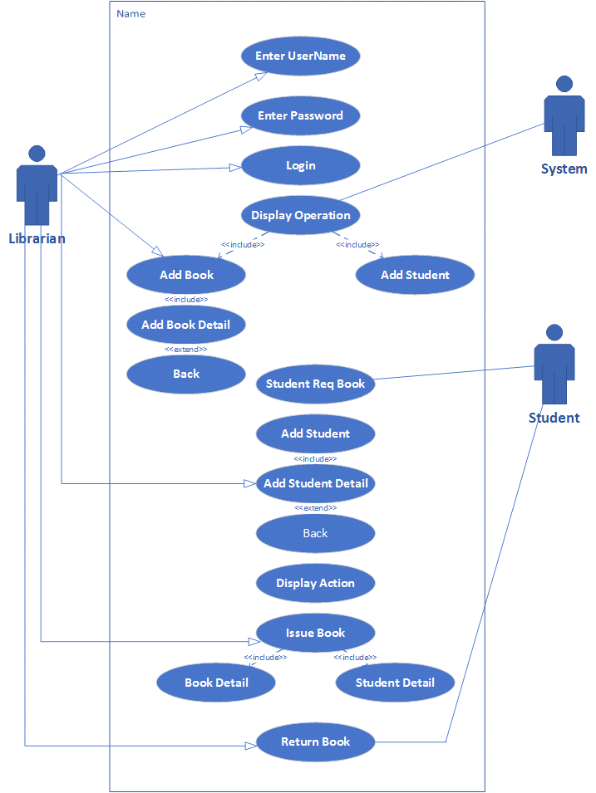
* use cases with narratives.

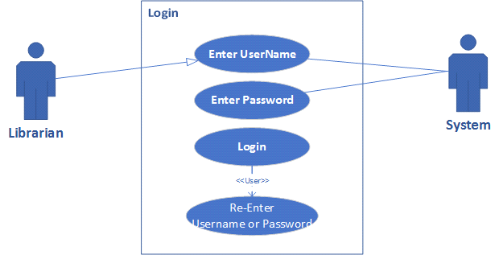

|  |  |  |
| --- | --- | --- |
| **Use Case Name:** | Login | |
| **ID:** | 01 | |
| **Actors Involved:** | Librarian ,System | |
| **Brief Description** | Actor enters the user name and password to login to the system. | |
|  |  | |
|  |  | |
| **Normal Flow of Events:** | **Actor Action** | **System Response** |
| * Enter user name and password. * Clicks the Login button. | * System displays Operation or Actions. * System displays error message on invalid login. |

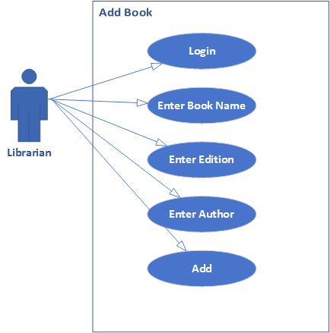

|  |  |  |
| --- | --- | --- |
| **Use Case Name:** | Add Book | |
| **ID:** | 02 | |
| **Actors Involved:** | Librarian | |
| **Brief Description** | Actor enters the user name and password to login to the system.  and add book name ,Edition and Author | |
|  |  | |
|  |  | |
| **Normal Flow of Events:** | **Actor Action** | **System Response** |
| * Enter user name and password. * Clicks the Login button. * Enter Book Name * Enter Edition * Enter Author | * System displays message Add new Book |

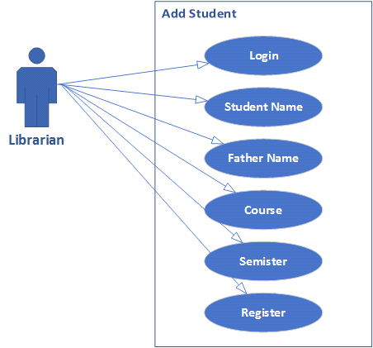

|  |  |  |
| --- | --- | --- |
| **Use Case Name:** | Add Student | |
| **ID:** | 03 | |
| **Actors Involved:** | Librarian , | |
| **Brief Description** | Actor enters the user name and password to login to the system.  and add student name ,father name , course , and semister | |
|  |  | |
|  |  | |
| **Normal Flow of Events:** | **Actor Action** | **System Response** |
| * Enter user name and password. * Clicks the Login button. * Add Student Name * Add Father Name * Add Course * Add Semister | * System displays message on Add student |

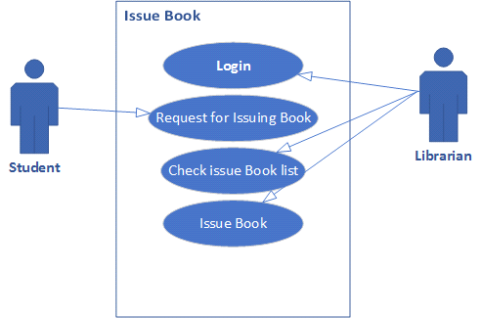

|  |  |  |
| --- | --- | --- |
| **Use Case Name:** | Issue Book | |
| **ID:** | 04 | |
| **Actors Involved:** | Librarian ,Student | |
| **Brief Description** | Actor enters the user name and password to login to the system.  Stuent Request for issuing Book Librarian check issue book list  and then book issue | |
|  |  | |
|  |  | |
| **Normal Flow of Events:** | **Actor Action** | **System Response** |
| * Enter user name and password. * Clicks the Login button. * Student Request for Book * Librarian check issue Book * Librarian issue Book | * System displays message issue Book |

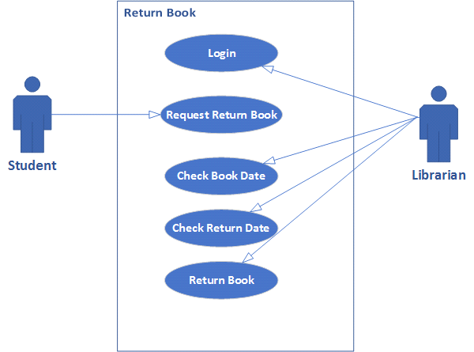

|  |  |  |
| --- | --- | --- |
| **Use Case Name:** | Return Book | |
| **ID:** | 05 | |
| **Actors Involved:** | Librarian ,Student | |
| **Brief Description** | Actor enters the user name and password to login to the system.  Student Request Return Book Librarian check book date and return date and then return | |
|  |  | |
|  |  | |
| **Normal Flow of Events:** | **Actor Action** | **System Response** |
| * Enter user name and password. * Clicks the Login button. * Student Request Return Book * Librarian check book date * Librarian check return date * Book Return | * System displays message on Return Book. |

* Finally, you need to develop an ERD/data flow or sequence diagram, whichever suits your project.
* **sequence diagram**

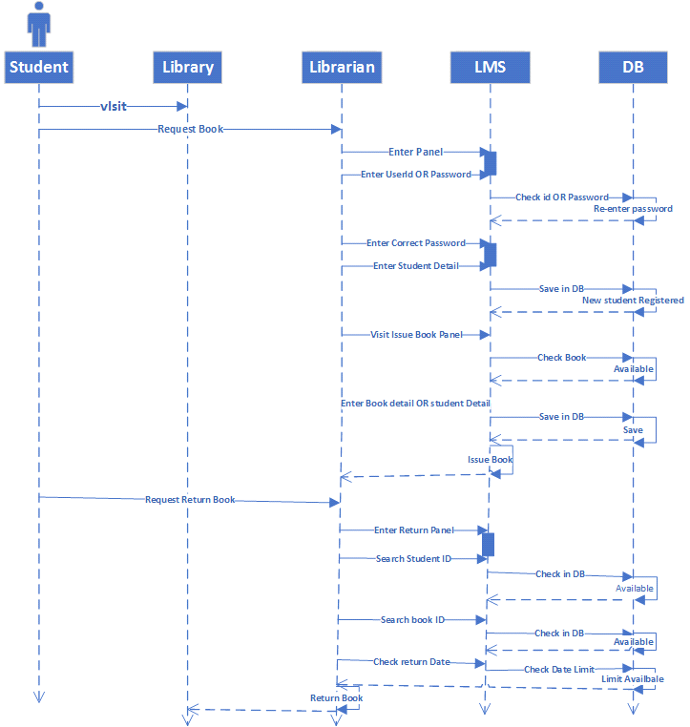

**Phase 4: Usability**

* Design the user interface using paper prototype and wireframes for your project. Follow all the rules that are discussed in the lecture.

**PROTOTYPE**

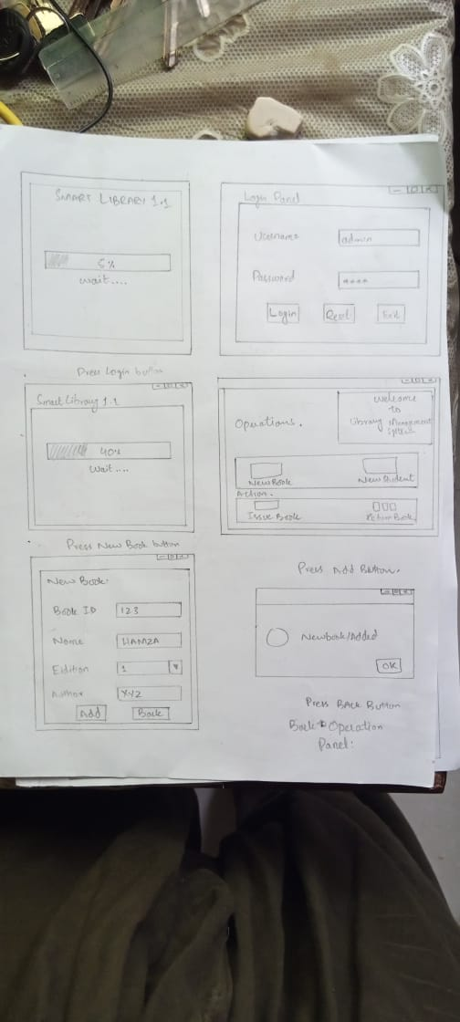

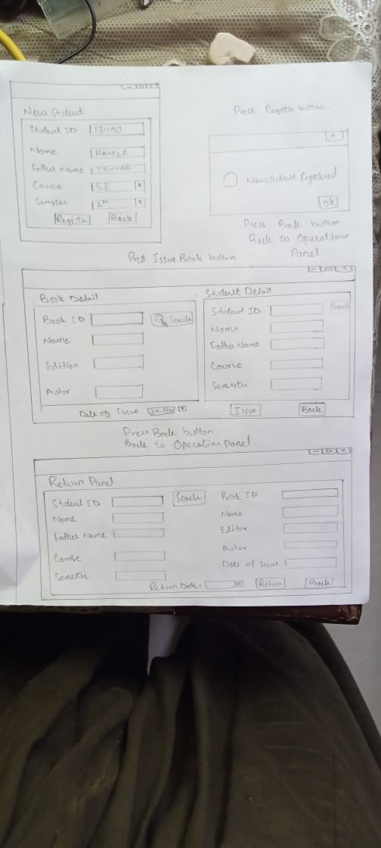

**Wireframes**

